**Hummingbird – Rhino-Grasshopper – Proof Files – 2020**

This set of files is used to develop and debug the components. It can also be used by users to demonstrate that they can use the components in a simple example, before attempting more complicated uses.

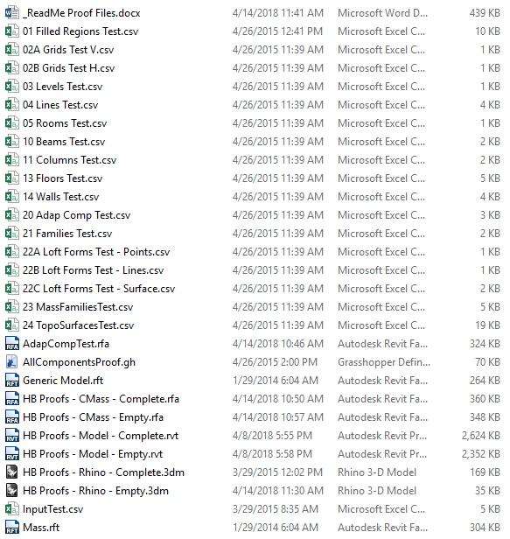

Files:

_ReadMe Proof Files.doc: This document.

01 – 24 *.csv: The files generated by “AllComponentsProof.gh. (These are provided in their completed form but would normally be created by the testing process.

InputTest.csv: The file used to test input to Rhino from Revit. (Not clear how this was created?)

AdapCompTest.rfa: Revit family already contained in Revit test file as required by “20 Adap Comp Test.csv.

AllComponentsProof.gh: Rhino-Grasshopper file used to create test .csv files for input to Revit and to utilize file from Revit for input to Rhino.

Generic Model & Mass.rft: Revit family template options required by “23 MassFamiliesTest.csv”. The path to one of these files must be set in the Revit Hummingbird “Create Elements from File” dialog box.

HB Proofs - *.rfa & rvt: Empty and complete versions of the Revit hosts used to test the .csv files. (The .rfa file is for the “22 Loft Forms *” files.) The empty version is used for the test; the complete version is just for reference.

HB Proofs - *.3dm: Empty and complete versions of the Rhino hosts used to create the test .csv file output from Rhino and the input from Revit.

Workflow:

The paths in the “AllComponentsProof.gh” file point to “C:\temp” and it is easiest to do the testing from this location.

1. Rhino -> Revit Workflow:

The primary workflow is to open the “HB Proofs - Rhino - Empty.3dm” Rhino file. Then, run Grasshopper and open the “AllComponentsProof.gh” project. This will create all of the .CSV files in the set except for the “InputTest.csv” file (see item 2.) The various .CSV files can be used with the WhiteFeet Model Builder to create the geometry in the “HB Proofs – Model.rvt” and “HB Proofs – ConceptMass.rfa” files.

2. Revit -> Rhino Workflow:

The “InputTest.csv” file has been created as a typical output from Revit. (No actual Revit output process is provided here.) Using the same “HB Proofs - Rhino - Empty.3dm” Rhino file, running Grasshopper, and opening the “AllComponentsProof.gh” project will create the test geometry in Rhino.

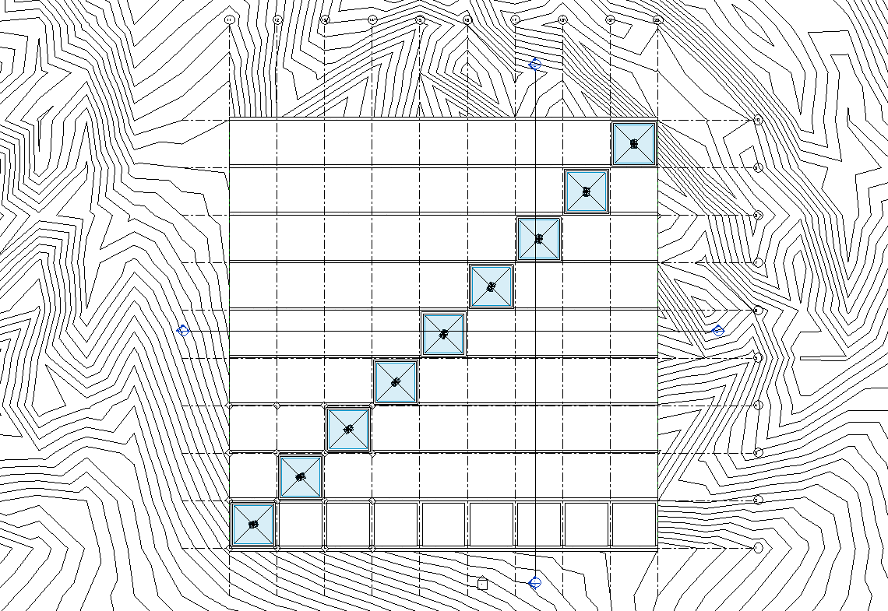

*2D View of Geometry Created in Revit*

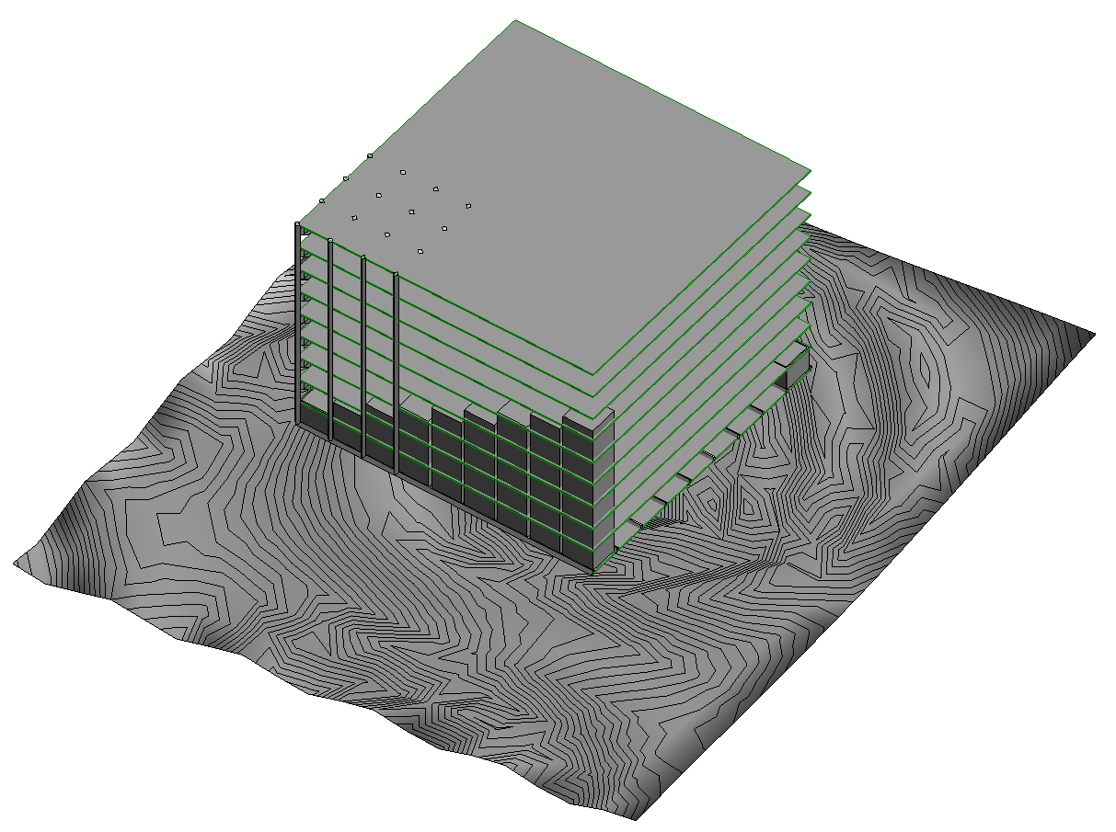

*3D View of Geometry Created in Revit*

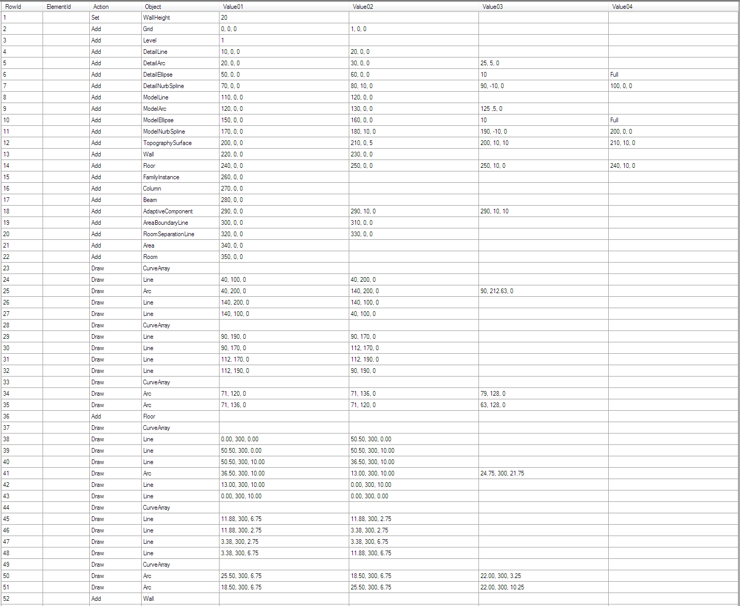  
*Test Data for Revit to Rhino Test (InputTest.csv) Viewed in Excel*

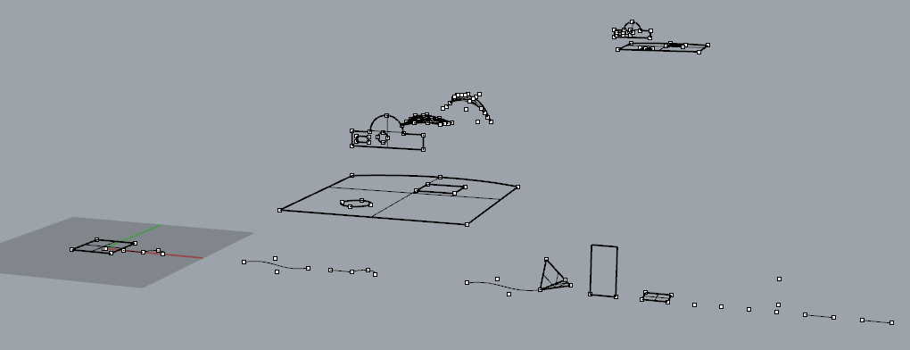  
*Results of Test Data for Revit to Rhino Test (InputTest.csv) in Rhino*